***CUSTOR PORTAL SYSTEM***

***BUSINESS REQIRMENT DOCUMENT***



**Table of Content**

**1.Executive Summary 1**

**2.Project Objectives 1**

**3.Project Scope 2**

**Project Objectives Overview 2**

**3.1 Milestones 2**

**3.2 Project Deliverables 2**

**3.3 Acceptance Criteria 3**

**4.Component Diagram 3**

**5.Project Requirements 4**

**6.Non-Functional Requirements 4**

**7.User Stories 5**

**8.Stakeholders 5**

**9.Constraints 6**

**10.Assumptions and Dependencies 6**

**10.1 Assumptions 6**

**10.2 Dependencies 6**

**11.Risk Management 7**

**12.Future Scalability and Mobile Readiness 7**

**13.Deadlines 8**

**14.Testing and Quality Assurance Plan 9**

**15.Cost Benefit Analysis 10**

**15.1 Costs 10**

**15.2 Benefits 10**

**16.Glossary 12**

**17.Appendix 13**

* **Project Overview**

This Business Requirements Document outlines the design, scope, and functionality of the Custor Portal System—an internal web-based platform developed for Custor Computing to enhance collaboration, training, and performance tracking among interns, junior staff, mentors, and administrators.

The system aims to centralize project management, document sharing, and feedback mechanisms through role-based access and Kanban-style task workflows. Built with Angular and ASP.NET Core, the project targets deployment within a 3–4 week internship cycle.

Key features include secure authentication, versioned document uploads, real-time dashboards, and a centralized training module.

The document details objectives, deliverables, milestones, stakeholders, technical constraints, and a cost-benefit analysis, concluding with strategic recommendations for future improvements, such as analytics, gamification, and mobile readiness.

## 1.Executive Summary

The Custor Portal System is an internal web-based platform designed to streamline team collaboration at Custor Computing. It addresses inefficiencies caused by the lack of centralized tools for interns and junior staff, enabling project tracking, document sharing, communication, and performance visibility. The portal aims to reduce onboarding time, enhance employee engagement, and provide mentors with real-time project insights, improving productivity and accountability within a 3–4 week internship timeline.

## 2.Project Objectives

The following objectives are specific, measurable, attainable, relevant, and time-bound (SMART):

* Reduce onboarding time for interns and junior staffby 20% within 3 months of deployment by centralizing training materials.
* Increase employee engagement by 15% within 6 months, measured through task participation and feedback surveys.
* Centralize training resources (videos, quizzes, PDFs) into a single platform by the end of the 4-week development period.
* Achieve a 25% reduction in task miscommunication within 3 months through enhanced collaboration features.
* Ensure 100% adoption of the mentor dashboard for real-time progress visibility within 2 months of deployment.
* Provide a centralized system for project-based collaboration, fully implemented by Day 20, enabling seamless interaction across teams.
* Allow interns and employees to form project teams and assign tasks, with 100% functionality by Day 15, measurable by successful team creation and task assignment.
* Include document uploads with version tracking, fully operational by Day 12, verified by successful upload and version retrieval.
* Enable mentors and leads to monitor project status and provide feedback, achieving 100% mentor usage within 2 months of deployment, measured by feedback submissions.

## 3.Project Scope

### Project Objectives Overview

The Custor Portal System will facilitate collaboration among interns, junior staff, mentors, and executives through a web-based platform. It includes role-based authentication (Intern, Mentor, Admin), Kanban-style task management, document upload with version tracking, comment threads for communication, and a mentor dashboard. Built with Angular (frontend) and ASP.NET Core (backend), the project will be completed within a 3–4 week internship timeline.

### 3.1 Milestones

* Scope and Objectives Finalization (Betel Yemanebirhan) – Day 3
* Core Modules (Task Management, Document Upload, Dashboard) Completion – Day 15
* Internal Demo, Feedback, and Final Deployment – Day 20

### 3.2 Project Deliverables

* Web-based portal with JWT-based role authentication for Interns, Mentors, and Admins.
* Kanban-style project and task management modules for task creation and tracking.
* Document upload system supporting training materials (videos, quizzes, PDFs) with version tracking.
* Communication feature with comment threads for team collaboration.
* Mentor dashboard for real-time project status and feedback.
* Progress overview and reporting system for team performance.

### 3.3 Acceptance Criteria

* The portal must support secure JWT authentication with role-based access for Interns, Mentors, and Admins.
* Task management module must enable task creation, assignment, and status updates in a Kanban-style interface.
* Document upload system must support versioning and storage of training materials (videos, quizzes, PDFs).
* Mentor dashboard must provide real-time project progress and allow feedback submission.
* All features must be accessible via a web browser with a maximum page load time of 2 seconds.
* The system must pass internal testing by Day 17 and be deployable by Day 20.

### 4.Component Diagram

**Description**: A UML component diagram illustrating:

* **Frontend (Angular)**: Components for Dashboard, Task Board, Document Upload, and Training Module.
* **Backend (ASP.NET Core)**: API services for authentication (JWT), task management, document versioning, and feedback.
* **Database (PostgreSQL)**: Stores user data, tasks, documents, and feedback.

**Interactions**: HTTP requests between frontend and backend, secured by JWT.

## 5.Project Requirements

|  |  |  |
| --- | --- | --- |
| **Requirement** | **Priority Level** | **Description** |
| User Roles | High | Implement role-based authentication (JWT) for Admin, HR, Employee (Intern/Junior Staff), and Manager (Mentor) to ensure secure access to relevant features. |
| Dashboard with Progress Tracking | High | Develop a Kanban-style dashboard for task creation, assignment, and progress tracking with visual indicators for project milestones. |
| Document Upload & E-Signature Support | Medium | Enable upload of training materials (videos, quizzes, PDFs) with version tracking and e-signature functionality for document approval. |
| Training Modules | Medium | Provide a centralized module for accessing training resources (videos, quizzes, PDFs) based on user roles. |
| Task Checklists & Reminders | High | Include task checklists for interns and junior staff, with automated reminders for deadlines integrated into the task management system. |
| Feedback & Surveys | Medium | Enable mentors to provide feedback via comment threads and support survey creation for measuring employee engagement. |

## 6.Non-Functional Requirements

|  |  |  |
| --- | --- | --- |
| **Requirement** | **Priority** | **Description** |
| Performance | High | System supports 100 concurrent users with <2-second page load time. |
| Security | High | Data encrypted in transit (HTTPS) and at rest; GDPR-compliant storage. |
| Usability | Medium | Intuitive UI with minimal training required for non-technical users. |
| Scalability | Medium | System can scale to 1,000 users by Q3 2026 with microservices architecture. |

## 7.User Stories

* **Intern**: As an intern, I want to create and assign tasks on a Kanban board so that I can collaborate with my team efficiently.
* **Mentor**: As a mentor, I want to view real-time project progress on my dashboard so that I can provide timely feedback.
* **Admin**: As an admin, I want to manage user roles via JWT authentication to ensure secure access to the portal.
* **HR**: As an HR member, I want to upload training materials with version tracking so that interns can access the latest resources.
* **Team Leader**: As a team leader, I want to monitor task checklists and send reminders to ensure deadlines are met.

## 8.Stakeholders

|  |  |  |
| --- | --- | --- |
| **Name** | **Role** | **Responsibilities** |
| Betel Yemanebirhan | Project Manager | Oversee project execution, finalize scope, coordinate tasks, Develop Back-end and ensure timely delivery. |
| Eden Getachew | Software Engineer | Develop frontend components and contribute to BRD documentation. |
| Henok | Software Engineer | Design backend architecture,develop front end components and contribute to SRS documentation. |
| Yabsra | Team Leader | Support development and testing activities. |
| Software Development Department | Stakeholder | Provide technical guidance, review system architecture, and ensure alignment with company standards. |
| HR & Project Management Team | Stakeholder | Ensure portal aligns with HR processes and project management needs, provide feedback on usability. |
| Company Executives | Stakeholder | Approve project objectives, monitor progress, and ensure strategic alignment. |
| Internship Program Coordinators | Stakeholder | Provide feedback on portal features and ensure alignment with internship goals. |
| Intern Mentorship Leaders | Stakeholder | Monitor intern progress, provide feedback via the portal, and ensure mentorship goals are met. |

## 9.Constraints

* Timeline: Complete the project within a 3–4 week internship period.
* Team Experience: Development team consists of interns with limited full-stack development experience.
* Technology Stack: Restricted to Angular (frontend) and ASP.NET Core (backend) per company mentor approval.
* Resource Access: Limited access to company systems and resources may impact development speed.
* Scope Limitation: Excludes mobile app development and third-party integrations (e.g., email/calendar).

## 10.Assumptions and Dependencies

### 10.1 Assumptions

* All users (interns, mentors, admins) have basic web navigation skills.
* Company infrastructure supports Angular and ASP.NET Core deployment.
* Training materials are provided by HR by Day 10.

### 10.2 Dependencies

* Availability of cloud hosting (e.g., Azure) by Day 5.
* Mentor availability for feedback sessions on Days 17 and 22.
* Access to PostgreSQL database confirmed by Day 7.

## 11.Risk Management

To ensure project success, the following risks, their potential impacts, and mitigation strategies have been identified:

|  |  |  |  |
| --- | --- | --- | --- |
| **Risk** | **Impact** | **Likelihood** | **Mitigation Strategy** |
| **Development Delays** | Missed milestones, delayed deployment | Medium | Break tasks into smaller sprints, monitor progress daily, and involve mentors early. |
| **Technology Limitations** | Limited Angular/ASP.NET Core expertise | High | Provide training sessions, leverage mentor guidance, and use online resources. |
| **Resource Constraints** | Slowed development due to limited system access | Medium | Secure access early, use cloud-based development environments (e.g., GitHub Codespaces). |
| **Scope Creep** | Increased timeline and costs | Low | Lock scope by Day 3, prioritize high-priority features, and defer enhancements. |
| **Testing Failures** | Bugs in production, poor user experience | Medium | Conduct unit and integration testing by Day 15, involve stakeholders in beta test |

## 12.Future Scalability and Mobile Readiness

To ensure the Custor Portal System remains relevant, the following scalability and mobile readiness plans are proposed:

* **Mobile Responsiveness**: Design the Angular frontend with responsive layouts using CSS frameworks like Bootstrap to ensure compatibility with mobile browsers by Q2 2026.
* **Mobile App Development**: Plan a native mobile app (iOS/Android) in Phase 2 (post-internship) using Flutter or React Native to enhance accessibility.
* **Scalability Enhancements**: Implement a microservices architecture in ASP.NET Core to handle increased user loads, targeting 1,000 concurrent users by Q3 2026.
* **Analytics Integration**: Add analytics modules (e.g., Power BI integration) for advanced reporting on user engagement and task completion by Q4 2026.
* **Gamification Features**: Introduce badges and leaderboards to boost engagement, planned for Q1 2027.

## 13.Deadlines

**Days 1–3: Form Team & Scope Setup**  
Assign roles, set up tools, research business goals, and share objectives.

**Days 3–4: Finalize Plan & Kickoff**  
Approve Charter, draft SRS assumptions, and hold official team kickoff.

**Days 5–11: Define & Design**  
Document functional requirements, plan API/security, set up backend and UI structure, and finalize the data model.

**Days 12–21: Development & Integration**  
Build and integrate core features (tasks, uploads, dashboard), and perform backend and UI testing.

**Days 22–26: Analysis & Feedback**  
Demo to mentor, gather feedback, and refactor based on system review.

**Days 27–32: Improvements**  
Apply feedback, complete role-based logic, polish UI/UX, and finalize documentation.

**Days 32–35: Control & Deployment**  
Deploy system, test, get mentor sign-off, and prepare user materials.

**Days 36–38: Closeout**  
Present final project and complete all documentation.

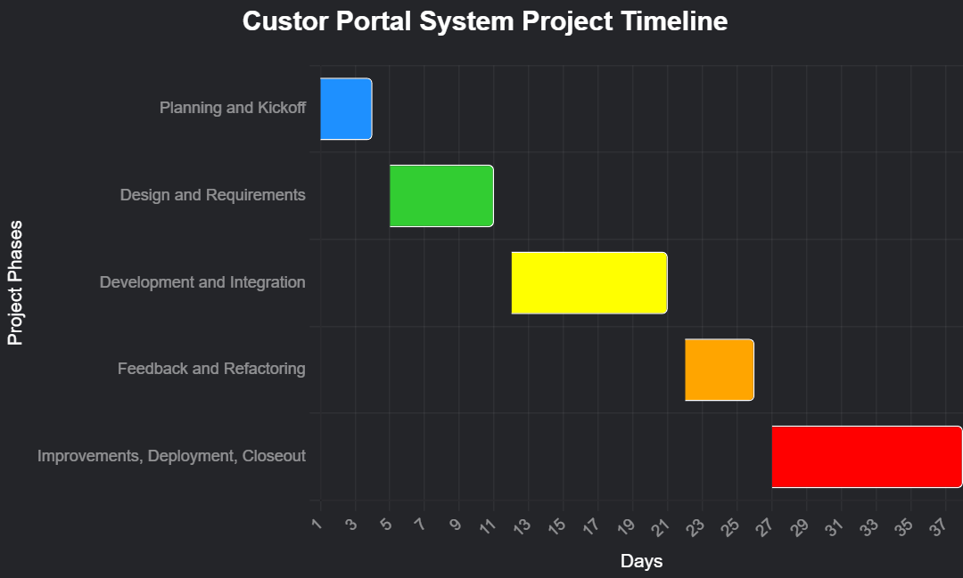

**Figure 1: Custor Portal System Project Timeline**

## 14.Testing and Quality Assurance Plan

* **Unit Testing**: Test components (e.g., JWT authentication, task creation) using Jasmine (Angular) and xUnit (ASP.NET Core) by Day 15.
* **Integration Testing**: Verify API endpoints and database interactions using Postman by Day 16.
* **User Acceptance Testing (UAT)**: Conduct UAT with mentors and interns on Day 17 to validate usability and functionality.
* **Performance Testing**: Ensure <2-second page load time using browser developer tools by Day 18.
* **Bug Tracking**: Use GitHub Issues to log and resolve defects by Day 20

## 15.Cost Benefit Analysis

### 15.1 Costs

|  |  |  |  |  |  |
| --- | --- | --- | --- | --- | --- |
| **No.** | **Category** | **Item** | **Quantity** | **Price** | **Total** |
| 1 | Development | Developer Hours (Interns) | 4 interns x 120 hours | $0 (Internship) | $0 |
| 2 | Infrastructure | Cloud Hosting (Development) | 1 month | $50 | $50 |
| 3 | Tools | Development Tools (GitHub, IDEs) | Free tier | $0 | $0 |
| 4 | Training | Mentor Guidance | 10 hours | $0 (Internal) | $0 |
| 5 | Testing | Testing Environment Setup | 1 setup | $20 | $20 |
| **Total Cost** |  |  |  |  | **$70** |

### 15.2 Benefits

|  |  |
| --- | --- |
| **Description** | **Price** |
| Reduced onboarding time (20% faster, ~8 hours per intern) | $800 (based on intern value) |
| Improved employee engagement (15% increase via surveys) | $500 (productivity gain) |
| Centralized training materials (reduced search time) | $300 |
| Enhanced collaboration (25% reduction in miscommunication) | $400 |
| Improved transparency (mentor dashboard adoption) | $200 |
| Improved transparency | $200 |

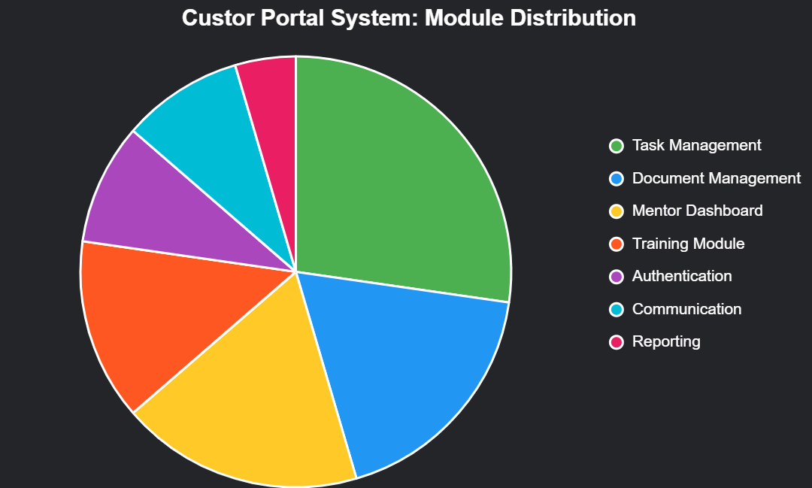

**Figure 1: Custor Portal System Module Distribution**

* The Portal System’s core modules based on their priority and development effort. Task Management (30%) and Mentor Dashboard (20%) lead due to their high-priority role in collaboration and progress tracking. Document Management (20%) and Training Module (15%) support resource handling and learning, while Authentication (10%), Communication (10%), and Reporting (5%) ensure security, interaction, and analytics.

This distribution aligns with the project’s objectives to streamline onboarding, enhance engagement, and centralize training within a 3–4 week timeline.

## 16.Glossary

|  |  |
| --- | --- |
| **Term** | **Description** |
| Kanban | A visual task management method using boards to track task progress. |
| JWT | JSON Web Token for secure role-based authentication. |
| Role-Based Access | Restricts system access based on user roles (Intern, Mentor, Admin). |
| Version Tracking | Manages and stores different versions of uploaded documents. |
| Mentor Dashboard | Interface for mentors to monitor project progress and submit feedback. |
| Training Module | Centralized system for accessing training materials (videos, quizzes, PDFs). |
| E-Signature | Electronic signature functionality for document approval. |

## 17.Appendix

* **Reference Materials**: Project charter (Custor.docx) for additional context.
* **Technical Notes**: The system will use Angular (frontend) and ASP.NET Core (backend), with PostgreSQL as the potential database (to be confirmed in SRS).
* **Feedback Plan**: Internal demo on Day 17 will include a stakeholder feedback session to refine features before final deployment.
* **Supporting Documents**: Initial scope draft shared by Betel on Day 2; early BRD sections drafted by Eden on Day 5.